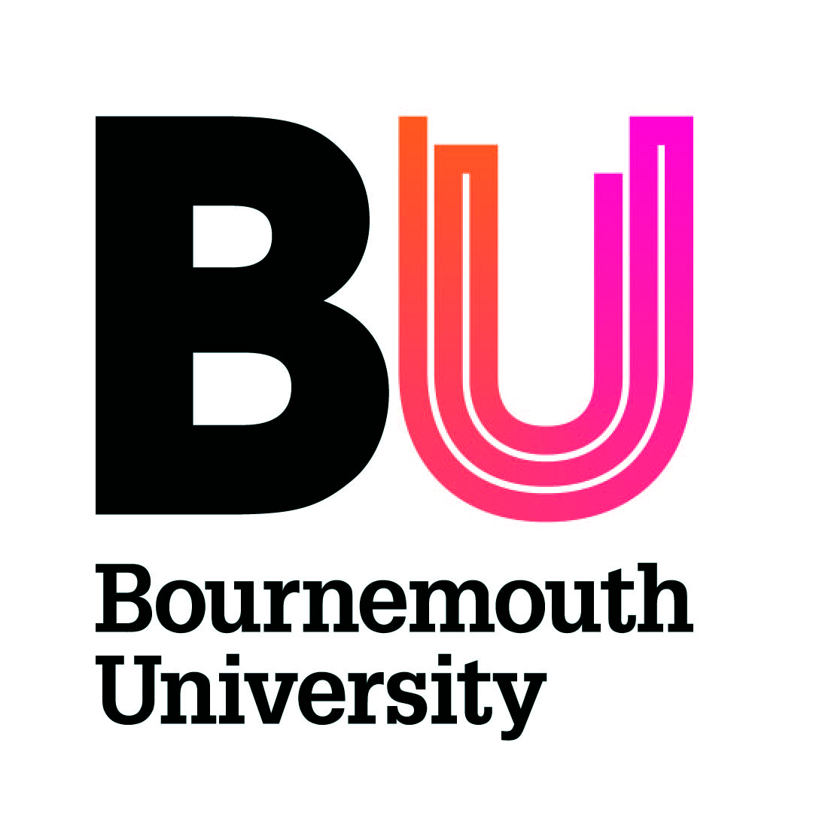

Intellectual Property Guidance

Examples of Intellectual Property Rights include:

Copyright (Copyright protects the form of expression of ideas and not the ideas themselves as such Copyright does not have to be registered for the right to arise, so this needs to be considered carefully).

- Patents (Patents are registered rights relating to inventions. Patents are not valid if the invention is published before the application is filed. It is very important that potentially patentable inventions are identified early and discussed before any publication or public presentation or announcement by us or the KTP partner).

- Designs - registered and unregistered (Design rights (unregistered) protect the appearance of functional products or parts of products, not aesthetic or decorative designs. These rights arise when the object is created or the design is recorded (eg in a drawing) and do not have to be registered. Designs can also be protected by registration – including decoration and ornamentation).

- Trade marks (If a new trademark may arise as part of the project we will need to consider whether it needs to be protected by registration and also whether there is a risk of infringing third party rights. Trademarks have to be distinctive and not merely descriptive).

- Domain names (Domain names are only likely to be relevant where the project involves the development of brands and trademarks).
- Database rights (If the project involves designing a database or collating information for the partner, then database rights may arise, and should be considered alongside copyright. If third party databases are used to deliver the project then we should also consider whether there is a risk of infringement by copying or extracting data).

- Semi-conductor chip topographies (If we are doing a project where chip design is a key part of the work, this should be explored in more detail).

- Protection of plant varieties (There is a special type of statutory IP right created to protect investment in new varieties of plants. If we are doing a project where this is a key part of the work, this should be explored in more detail).

- Performers’ rights (Performers are entitled to various rights in their live performances, and these rights will need to be considered if the project involves either making recordings or disseminating them).

- Related rights: trade secrets/know how/trading reputation (If the project involves trade secrets or substantial amounts of specialist know how then a non-disclosure agreement will be required (see the note above). It is important that both parties are able to use know how gained from these projects in their on-going activities).

Summary of key intellectual property rights

A brief summary of some of the key intellectual property rights and how they arise is given below to help you identify if these arise or are relevant in your project – please contact legal services if you need more detailed advice.

Copyright

Copyright protects the form of expression of ideas and not the ideas themselves as such (ideas may be protected by confidentiality). It is a right to prevent copying and it does not matter if a similar or identical work already exists if it has not been copied.

To be protected by copyright the work must be original. It can exist in written materials and software code as well as databases (where there is creative input), so if we are using existing software to deliver the project or the project involves writing new software, or if the project deliverables will include manuals, compilations of data, marketing strategies or reports, for example, copyright will be relevant.

Copyright does not have to be registered for the right to arise. The © symbol (usually with a name and a date) indicates an assertion of ownership in the copyright and a warning to those who might otherwise copy the material but adding this does not itself create copyright.

Where we are involved in a project which relies on previous research or published material, we should check that the relevant permissions have been obtained where required so that there is no infringement of third party rights.

Patents

Patents are registered rights which have to be applied for and relate to inventions, and if granted they can be used to prevent others doing the same thing.

They typically involve physical objects or processes, or chemical products (such as drugs) but there can be business process or software patents if the software or the process has a technical function which involves an invention.

The physical object or process does not have to have been manufactured or in operation to apply for a patent, an application can be made on the basis of drawings.

Patents will not be registered or can be invalidated if what they do is “obvious” or has been done by someone before, and they are also not valid if the invention is published before the application is filed.

It is therefore very important that if the project involves work on something which might be patentable, this is identified early and applications are made, and that this is discussed before any publication or public presentation or announcement by us or the KTP partner.

A patent can be infringed even if you don’t know about it (ignorance is no defence) so if we are working on a project where others might be actively involved in applying for patents, a patent search should be carried out – this might be the case where the KTP relates to projects developing medical appliances or mechanical devices, for example.

Designs - registered and unregistered

Design rights (unregistered) protect the appearance of functional products or parts of products, not aesthetic or decorative designs.

Like copyright, these rights arise when the object is created or the design is recorded (eg in a drawing) and do not have to be registered, and the existence of a right prevents copying. To be protected a right must be original and not depend on something else, as well as not being a surface decoration.

Designs can also be protected by registration – designs that can be registered include the lines, contours, colours, shape, texture or materials of a product or its ornamentation (such as surface pattern, character images, logos or software icons), and this can be used to protect packaging, get-up, graphic symbols and typographic typefaces. A three-dimensional design can be protected as well as a two-dimensional design. The design must be new (so not a copy of something else) and have individual character.

As with patents, there will be a problem if the design is widely disclosed before it is registered, but there is a 12 month grace period for applications.

If the KTP project involves the design of products, packaging or on-line material, there may be design rights and we should consider both registration and ownership. If the project is in a field where design is very important, then it may be necessary to consider whether there is any risk of infringement or copying a third party design.

Trade marks

Trade marks can also be protected whether or not they are registered.

Trade marks may be relevant to your project because a new one will be created in which case we will need to consider whether it needs to be protected by registration and also whether it is too close to one already in use and therefore cannot be used without a risk of infringing third party rights.

Trade marks have to be distinctive and not merely descriptive (eg we couldn’t register “student accommodation services” unless something special was associated with the mark because of the way we had used it over a period of time, or unless it was associated with a distinctive logo).

Registered trade marks are registered in relation to “classes” of use, and are only protected for that type of use.

Trade marks which have been registered can be challenged if they are not actually used over a period of time by the person who has registered them.

If a new brand or mark is being developed as part of the project, searches will be required to ensure that any new mark does not infringe third party rights.

Domain names

A domain name is a label linked to an Internet Protocol address. Domain names are assigned by a number of administrative bodies. Because they are often linked to brands, and they are used for navigation on the internet, they have an intrinsic value of their own. Domain names for important brands are sometimes acquired by so-called “cyber-squatters” who seek high payments from the brand owners to acquire the brand, and critics of a business or brand may set up a site with a similar name to the main brand site to collate complaints and criticism.

As there are so many top level domains, businesses rarely register all the possible variations of their brand. If we are involved in a project which includes website or brand development, it will be important to ensure that the company considers registering any domain name that may be relevant.

It is unlikely that BU will have any ownership interest in a domain name arising from a collaboration unless it includes BU or a trademark or brand that we also have ownership rights in.

Database rights

As well as copyright, which may arise in relation to the structure of a database (if there is some creative input other than just collecting the data) and also the individual items of content, there is a separate database right which applies to compilations of data (whether electronic or not) if there has been a substantial investment in obtaining, verifying or presenting the contents of the database.

If the project involves designing a database or collating information for the partner, then database rights may arise, and should be considered alongside copyright.

If third party databases are used to deliver the project then we should also consider whether there is a risk of infringement by copying or extracting data.

Semi-conductor chip topographies

These are a special type of unregistered design right. It it is rarely relied on, with patents, design rights and copyright being more relevant. If we are doing a project where chip design is a key part of the work, this should be explored in more detail.

Protection of plant varieties

There is a special type of statutory IP right created to protect investment in new varieties of plants. If we are doing a project where this is a key part of the work, this should be explored in more detail.

Performers’ rights

Performers are entitled to various rights in their live performances, including the right to be identified as the performer of a performance, to object to derogatory treatment of a performance, to copy a recording, issue copies to the public (including over the internet) and a right to equitable remuneration for the rental and exploitation of recordings of their performances. The performer's consent is required to the recording and exploitation (broadcasting, reproduction, distribution and so on) of the performances.

Some of these rights can be sold or assigned to third parties or waived in contracts. If the KTP project involves making or broadcasting recordings then these will need to be considered.

Related rights: confidential information/trade secrets/know how/trading reputation/ “passing off”

These are unregistered rights. If the project involves trade secrets or substantial amounts of know how then a non-disclosure agreement will be required, and we may also need to consider the provisions relating to residual knowledge which is not protected by other IP but remains with the collaborator once the project is finished.

